A
Industrial-Oriented Mini Project On
AI-BASED DETECTION OF CHRONIC HEART FAILURE FROM HEART SOUNDS USING MACHINE LEARNING AND DEEP LEARNING

(Submitted in partial fulfilment of the requirements for the award of Degree)
BACHELOR OF TECHNOLOGY
In
COMPUTER SCIENCE AND ENGINEERING
By
Rontala Sandana Aini | (237R1A05BQ)
Mandati Varun Reddy | (237R1A05AZ)
Chakali Karthik | (247R5A0538)

Under the Guidance of
Dr. Punyaban Patel
(Associate Professor)


DEPARTMENT OF COMPUTER SCIENCE AND ENGINEERING
CMR TECHNICAL CAMPUS
UGC AUTONOMOUS
(Accredited by NAAC, NBA, Permanently Affiliated to JNTUH, Approved by AICTE, New Delhi) Recognized Under Section 2(f) & 12(B) of the UGCAct.1956, Kandlakoya (V), Medchal Road, Hyderabad-501401.
May-2026

DEPARTMENT OF COMPUTER SCIENCE AND ENGINEERING


CERTIFICATE

This is to certify that the project entitled “Ai-Based Detection Of Chronic Heart Failure From Heart Sounds Using Machine Learning And Deep Learning” being submitted by Rontala Sandana Aini (237R1A05BQ), Mandanti Varun Reddy (237R1A05AZ) & Chakali Karthik (247R5A0538) in partial fulfilment of the requirements for the award of the degree of B.Tech in Computer Science and Engineering to the Jawaharlal Nehru Technological University Hyderabad, during the year 2025-26.

The results embodied in this thesis have not been submitted to any other University or
Institute for the award of any degree or diploma.

Dr. Punyaban Patel Dr. Nuthanakanti Bhaskar
Associate Professor HoD
INTERNAL GUIDE

Dr. A. Raji Reddy Signature of External Examiner DIRECTOR

Submitted for viva voice Examination held on

ACKNOWLEDGEMENT
We take this opportunity to express our gratitude to the people who have been instrumental in the successful completion of this project, we take this opportunity to express our profound gratitude and deep regard to our guide Dr.Punyaban Patel, Associate Professor for his exemplary guidance, monitoring and constant encouragement throughout the project work. The blessing, help and guidance given by him shall carry us a long way in the journey of life on which we are about to embark.

We take this opportunity to extend our heartfelt appreciation to the Project Review
Committee (PRC) Coordinators—Dr.Punyaban Patel, Y Aparna, R Sriniketh, K.
Praveen Kumar—for their unwavering support, insightful guidance, and valuable inputs, which played a crucial role in steering this project through its various stages.

Our sincere appreciation also goes to Dr. V.Naresh Kumar, Head, for his encouragement and continuous support in ensuring the successful completion of our project.

We are deeply grateful to Dr. A. Raji Reddy, Director, for his cooperation throughout the course of this project. Additionally, we extend our profound gratitude to Sri. Ch. Gopal Reddy, Chairman, Smt. C. Vasantha Latha, Secretary and Sri. C. Abhinav Reddy, Vice-Chairman, for fostering an excellent infrastructure and a conducive learning environment that greatly contributed to our progress.

We also acknowledge and appreciate the guidance and assistance provided by the faculty and staff of CMR Technical Campus, whose contributions have been invaluable in bringing this project to fruition.

Lastly, we sincerely thank our families for their unwavering support and encouragement. We also extend our gratitude to the teaching and non-teaching staff of CMR Technical Campus for their guidance and assistance. Their contributions, along with the support of everyone who helped directly or indirectly, have been invaluable in the successful completion of this project.

Rontala Sandana Aini (237R1A05BQ)
Mandati Varun Reddy (237R1A05AZ)
Chakali Karthik (247R5A0538)

VISION AND MISSION
INSTITUTE VISION:
To Impart quality education in serene atmosphere thus strive for excellent in Technology and Research

INSTITUTE MISSION:
- To create state of art facilities for effective Teaching- Learning Process.

- Pursue and Disseminate Knowledge based research to meet the needs of Industry & Society.

- Infuse Professional, Ethical and Societal values among Learning Community.

DEPARTMENT VISION:
To provide quality education and a conducive learning environment in computer engineering that foster critical thinking, creativity, and practical problem-solving skills.

DEPARTMENT MISSION:
- To educate the students in fundamental principles of computing and induce the skills needed to solve practical problems.

- To provide State-of-the-art computing laboratory facilities to promote industry institute interaction to enhance student’s practical knowledge.

- To inculcate self-learning abilities, team spirit, and professional ethics among the students to serve society.

ABSTRACT

This project is titled as “Ai-Based Detection Of Chronic Heart Failure From Heart Sounds Using Machine Learning And Deep Learning ”. We present a method for CHF detection based on heart sounds. The method combines classic Machine-Learning (ML) and end-to-end Deep Learning (DL). The classic ML learns from expert features, and the DL learns from a spectro-temporal representation of the signal. The method was evaluated on recordings from 947 subjects from six publicly available datasets and one CHF dataset that was collected for this study. Using the same evaluation method as a recent PhysoNet challenge, the proposed method achieved a score of 89.3, which is 9.1 higher than the challenge’s baseline method. The method’s aggregated accuracy is 92.9% (error of 7.1%); while the experimental results are not directly comparable, this error rate is relatively close to the percentage of recordings labeled as ‘‘unknown’’ by experts (9.7%). Finally, we identified 15 expert features that are useful for building ML models to differentiate between CHF phases (i.e., in the decompensated phase during hospitalization and in the compensated phase) with an accuracy of 93.2%. The proposed method shows promising results both for the distinction of recordings between healthy subjects and patients and for the detection of different CHF phases. This may lead to the easier identification of new CHF patients and the development of home-based CHF monitors for avoiding hospitalizations.

LIST OF FIGURES
FIGURE NO |  | FIGURE NAME  Project Architecture of A Deep  Learning-Based Approach for  Inappropriate Content Detection and Classification of YouTube Videos  Dataflow Diagram of A Deep  Learning-Based Approach for Inappropriate Content Detection and Classification of YouTube Videos  Dataset directory structure with folders 'Safe Content and  Inappropriate Content' having all the training examples  Screenshot of the "Inappropriate  Content" Folder Showing  Sample Image Files  Screenshot of the "Safe Content" Folder Showing  Sample Image Files. | PAGE NO  14  17  23  23  24
Figure 3.1
Figure 3.2

Figure 4.1

Figure 4.2

Figure 4.3

TABLE OF CONTENTS

ABSTRACT i
LIST OF FIGURES ii
LIST OF TABLES v
- INTRODUCTION 1
  - PROJECT PURPOSE 1
  - PROJECT FEATURES 2
- LITERATURE SURVEY 3
  - REVIEW OF RELATED WORK 7
  - DEFINITION OF PROBLEM STATEMENT 9
  - EXISTING SYSTEM 9
  - PROPOSED SYSTEM 11
  - OBJECTIVES 12
  - HARDWARE & SOFTWARE REQUIREMENTS 13
    - HARDWARE REQUIREMENTS 13
    - SOFTWARE REQUIREMENTS 13
- SYSTEM ARCHITECTURE & DESIGN 14
  - PROJECT ARCHITECTURE 14

  - DESCRIPTION 15
  - DATA FLOW DIAGRAM 16
- IMPLEMENTATION 18
  - ALGORITHMS USED 18
  - SAMPLE CODE 25
- RESULTS & DISCUSSION 37
- VALIDATION 47
  - INTRODUCTION 47 6.2TEST CASES 48
    - UPLOADING DATASET 48
    - CLASSIFICATION 48
- CONCLUSION & FUTURE ASPECTS 49
  - PROJECT CONCLUSION 49
  - FUTURE ASPECTS 50
- BIBLIOGRAPHY 51
  - REFERENCES 51
  - GITHUB LINK 52

1.INTRODUCTION

AI-BASED DETECTION OF CHRONIC HEART FAILURE FROM HEART SOUNDS USING MACHINE LEARNING AND DEEP LEARNING

1.INTRODUCTION
Chronic heart failure (CHF) is a chronic, progressive condition underscored by the heart’s inability to supply enough perfusion to target tissues and organs at the physiological filling pressures to meet their metabolic demands. CHF has reached epidemic proportions in the population, as its incidence is increasing by 2% annually. In the developed world, CHF affects 1-2% of the total population and 10% of people older than 65 years. Currently, the diagnosis and treatment of CHF uses approximately 2% of the annual healthcare budget. In absolute terms, the USA spent approximately 35 billion USD to treat CHF in 2018 alone, and the costs are expected to double in the next 10 years . Despite the progress in medical- and device-based treatment approaches in the last decades, the overall prognosis of CHF is still dismal, as 5-year survival rate of this population is only approximately 50%. In the typical clinical course of CHF, we observe alternating episodes of compensated phases, when the patient feels well and does not display symptoms and signs of fluid overload, and decompensated phases, when symptoms and signs of systemic fluid overload (such as breathlessness, orthopnea, peripheral edema, liver congestion, pulmonary edema) can easily be observed. During the latter episodes, patients often require hospital admission to receive treatment with intravenous medications (diuretics, inotropes) to achieve a successful negative fluid balance and return to the compensation state. Early detection of HF worsening would allow a treating physician to adjust the patient’s medical management on an outpatient basis in a timely manner and thus avoid the need for a hospital admission. Currently, anexperienced physician can detect the worsening of HF by examining the patient and by characteristic changes in the patient’s heart failure biomarkers, which are determined from the patient’s blood. Unfortunately, clinical worsening of a CHF patient likely means that we are already dealing with a fully developed CHF episode that will most likely require a hospital admission. Additionally, in some patients, characteristic changes in heart sounds can accompany heart failure worsening and can be heard using phonocardiography. An example of a phonocardiogram (PCG) recording of a healthy subject is presented. In healthy subjects, 2 heart sounds are typically heard (called S1 and S2). S1 is caused by the closure of the mitral valve and ventricular wall in the early systole, S2 is caused by the closure of the aortic and pulmonary valves at the beginning of the diastole. Here, the interval between S1 and S2 is called systole, i.e., the contraction phase of the cardiac cycle, and the interval between S2 and S1 is called diastole, i.e., the relaxation phase of the cardiac cycle. Additional heart sounds (such as S3 and S4) can be heard in certain cardiac conditions and are never regarded as normal. In the case of CHF (in the course of decompensation), we can often hear a third sound (S3) that typically appears 0.1-0.2 s after the second sound, i.e., S2. Recently, it has been demonstrated that some physiological parameters, such as the occurrence of additional heart sounds or increased blood pressure in the pulmonary circulation, already start to appear several weeks before the CHF patient develops a clinically evident decompensation episode. This is also an important therapeutic window where outpatient-based treatment interventions can reverse CHF deterioration and return the patient to the compensated state without the need for a hospital admission. In recent years, many studies have proposed MachineLearning (ML) approaches for the automatic detection of different heart conditions using PCG signals recorded with a digital stethoscope . Nevertheless, methods that explicitly focus on CHF detection are quite scarce. The typical ML pipeline for the detection of different heart conditions is as follows: segmentation of the signals by detecting the “typical” heart sounds (i.e., S1 and S2), denoising of the signals, extracting individual frequency-domain and time-domain features, and learning a feature-based ML model (e.g., using ML algorithms, such as Random Forest or Support Vector Machine - SVM) that is capable of classifying healthy vs. unhealthy sounds. Most of the features currently used are based on medical and audio/signal analysis knowledgeHowever, a PCG recording that sounds unhealthy to one expert may sound healthy to another one; therefore, doctors never diagnose a CHF patient using only heart sounds, but rather use a holistic view of the patient instead (i.e., extensive medical history, blood pressure, laboratory tests, etc.). This uncertainty is one reason why 9.7% of the recordings in the recent PhysioNet cardiology challenge were actually labeled as “unknown” by experts, while the rest of the recordings were labeled as healthy or unhealthy. The recent advancements in Deep Learning (DL) suggest that end-to-end learning (i.e., ML models that learn directly from the raw data and no features are needed) can outperform the classic, feature-based ML. For example, DL has achieved breakthrough performance in tasks such as pattern recognition problems , image processing , natural language processing , speech and audio processing , and sensor data processing . For CHF detection, a successful combination of classic ML and end-to-end DL can outperform each single approach. The classic ML approach learns from a large body of expert-defined features, and the DL approach learns both from a time-domain (the raw PCG signal) representation of the signal and a temporaldomain representation (the spectrogram) of the signal. This approach was successful in our previous study of human activity recognition from smartphone sensor data . In addition to distinguishing the CHF patients and healthy individuals, we focus on detecting the CHF state (compensated vs. decompensated) based on the analysis of heart sound recordings. Our work builds upon the initial studies, where we demonstrated that it is possible to distinguish between healthy individuals and patients in a decompensated CHF episode using a stack of machinelearning classifiers and expert features, showing promising results on a limited dataset . We expand upon this approach using a considerably larger patient dataset, including six additional PhysioNet datasets, and an improved ML method that uses end-to-end DL. Furthermore, we investigate the differences in the heart sounds during the transition between the decompensated and recompensated states of CHF, with the aim of developing personalized monitoring models. Early detection of the worsening of CHF has the potential to reduce hospitalizations due to the worsening of the condition, which both improves the quality of life of patients and decreases the financial and logistic burden on the patient and the health system.

PROJECT PURPOSE
The primary purpose of this project is to enhance the early detection and diagnosis of chronic heart failure by analyzing heart sounds using advanced machine learning and end-to-end deep learning techniques. Traditional diagnosis often relies on manual auscultation and clinical expertise, which can be time-consuming and may lead to variability in interpretation. By implementing machine learning and end-to-end deep learning models, this project provides a more efficient, scalable, and accurate method for automatically detecting patterns in heart sound recordings associated with chronic heart failure. With the increasing prevalence of cardiovascular diseases worldwide, there is an urgent need for an AI-powered solution that can assist healthcare professionals in identifying chronic heart failure at an early stage and improving patient outcomes.

1.2 PROJECT FEATURES

This project incorporates several key features to improve the accuracy and efficiency of detecting chronic heart failure from heart sound recordings using machine learning and end-to-end deep learning techniques.
Automated Heart Sound Analysis:
The system employs advanced deep learning models to automatically extract meaningful features from heart sound signals (phonocardiograms). Convolutional Neural Networks (CNNs) are used to capture important acoustic patterns, while sequential models such as BiLSTM (Bidirectional Long Short-Term Memory) analyze the temporal relationships within heart sound signals. This combination improves the system’s ability to accurately detect abnormal patterns associated with chronic heart failure.
Multi-Class Classification:
Unlike traditional diagnostic approaches that simply classify heart sounds as normal or abnormal, this project adopts a multi-class classification approach. The system categorizes heart sound recordings into multiple classes such as Normal, Chronic Heart Failure, and Other Cardiac Abnormalities, enabling more detailed analysis. This helps medical professionals better understand the condition of the patient and supports more precise clinical decision-making.
Scalability & Real-Time Processing:
The proposed system is designed to efficiently process large datasets of heart sound recordings. With the support of optimized machine learning algorithms and GPU acceleration, the system can analyze heart sound signals quickly and accurately. This enables the possibility of real-time or near real-time screening in clinical environments, remote healthcare systems, and wearable medical devices.

2. LITERATURE SURVEY

2. LITERATURE SURVEY

Chronic heart failure represents a global pandemic, currently affecting over 26 million of patients worldwide. It is a major contributor in the death rate of patients with cardiovascular diseases and results in more than 1 million hospitalizations annually in Europe and North America. Methods for chronic heart failure detection can be utilized to act preventive, improve early diagnosis and avoid hospitalizations or even life-threatening situations, thus highly enhance the quality of patient’s life. In this paper, we present a machine-learning method for chronic heart failure detection from heart sounds. The method consists of: filtering, segmentation, feature extraction and machine learning. The method was tested with a leave-one-subject-out evaluation technique on data from 122 subjects, gathered in the study. The method achieved 96% accuracy, outperforming a majority classifier for 15 percentage points. More specifically, it detects (recalls) 87% of the chronic heart failure subjects with a precision of 87%. The study confirmed that advanced machine learning applied on real-life sounds recorded with an unobtrusive digital stethoscope can be used for chronic heart failure detection.
“Classification of normal/abnormal heart sound recordings: the PhysioNet/Computing in Cardiology Challenge 2016,”
In the past few decades heart sound signals (i.e., phono-cardiograms or PCGs) have been widely studied. Automated heart sound segmentation and classification techniques have the potential to screen for pathologies in a variety of clinical applications. However, comparative analyses of algorithms in the literature have been hindered by the lack of a large and open database of heart sound recordings. The PhysioNet/Computing in Cardiology (CinC) Challenge 2016 addresses this issue by assembling the largest public heart sound database, aggregated from eight sources obtained by seven independent research groups around the world. The database includes 4,430 recordings taken from 1,072 subjects, totalling 233,512 heart sounds collected from both healthy subjects and patients with a variety of conditions such as heart valve disease and coronary artery disease. These recordings were collected using heterogeneous equipment in both clinical and nonclinical (such as in-home visits). The length of recording varied from several seconds to several minutes. Additional data provided include subject demographics (age and gender), recording information (number per patient, body location, and length of recording), synchronously recorded signals (such as ECG), sampling frequency and sensor type used. Participants were asked to classify recordings as normal, abnormal, or not possible to evaluate (noisy/uncertain). The overall score for an entry was based on a weighted sensitivity and specificity score with respect to manual expert annotations. A brief description of a baseline classification method is provided, including a description of open source code, which has been provided in association with the Challenge. The open source code provided a score of 0.71 (Se=0.65 Sp=0.76). During the official phase of the competition, a total of 48 teams submitted 348 open source entries, with a highest score of 0.86 (Se=0.94 Sp=0.78).
"Speed up deep neural network based pedestrian detection by sharing features across multi-scale models,"
Deep neural networks (DNNs) have now demonstrated state-of-the-art detection performance on pedestrian datasets. However, because of their high computational complexity, detection efficiency is still a frustrating problem even with the help of Graphics Processing Units (GPUs). To improve detection efficiency, this paper proposes to share features across a group of DNNs that correspond to pedestrian models of different sizes. By sharing features, the computational burden for extracting features from an image pyramid can be significantly reduced. Simultaneously, we can detect pedestrians of several different scales on one single layer of an image pyramid. Furthermore, the improvement of detection efficiency is achieved with negligible loss of detection accuracy. Experimental results demonstrate the robustness and efficiency of the proposed algorithm.
“ImageNet classification with deep convolutional neural networks,”
We trained a large, deep convolutional neural network to classify the 1.3 million high-resolution images in the LSVRC-2010 ImageNet training set into the 1000 different classes. On the test data, we achieved top-1 and top-5 error rates of 39.7\% and 18.9\% which is considerably better than the previous state-of-the-art results. The neural network, which has 60 million parameters and 500,000 neurons, consists of five convolutional layers, some of which are followed by max-pooling layers, and two globally connected layers with a final 1000-way softmax. To make training faster, we used non-saturating neurons and a very efficient GPU implementation of convolutional nets. To reduce overfitting in the globally connected layers we employed a new regularization method that proved to be very effective.
“Inception-v4, inception-ResNet and the impact of residual connections on learning,”
Very deep convolutional networks have been central to the largest advances in image recognition performance in recent years. One example is the Inception architecture that has been shown to achieve very good performance at relatively low computational cost. Recently, the introduction of residual connections in conjunction with a more traditional architecture has yielded state-of-the-art performance in the 2015 ILSVRC challenge; its performance was similar to the latest generation Inception-v3 network. This raises the question: Are there any benefits to combining Inception architectures with residual connections? Here we give clear empirical evidence that training with residual connections accelerates the training of Inception networks significantly. There is also some evidence of residual Inception networks outperforming similarly expensive Inception networks without residual connections by a thin margin. We also present several new streamlined architectures for both residual and non-residual Inception networks. These variations improve the single-frame recognition performance on the ILSVRC 2012 classification task significantly. We further demonstrate how proper activation scaling stabilizes the training of very wide residual Inception networks. With an ensemble of three residual and one Inception-v4 networks, we achieve 3.08% top-5 error on the test set of the ImageNet classification (CLS) challenge.

“Recent trends in deep learning based natural language processing,”
Deep learning methods employ multiple processing layers to learn hierarchical representations of data, and have produced state-of-the-art results in many domains. Recently, a variety of model designs and methods have blossomed in the context of natural language processing (NLP). In this paper, we review significant deep learning related models and methods that have been employed for numerous NLP tasks and provide a walk-through of their evolution. We also summarize, compare and contrast the various models and put forward a detailed understanding of the past, present and future of deep learning in NLP.
“A neural probabilistic language model,”
A goal of statistical language modeling is to learn the joint probability function of sequences of words in a language. This is intrinsically difficult because of the curse of dimensionality: a word sequence on which the model will be tested is likely to be different from all the word sequences seen during training. Traditional but very successful approaches based on n-grams obtain generalization by concatenating very short overlapping sequences seen in the training set. We propose to fight the curse of dimensionality by learning a distributed representation for words which allows each training sentence to inform the model about an exponential number of semantically neighboring sentences. The model learns simultaneously (1) a distributed representation for each word along with (2) the probability function for word sequences, expressed in terms of these representations. Generalization is obtained because a sequence of words that has never been seen before gets high probability if it is made of words that are similar (in the sense of having a nearby representation) to words forming an already seen sentence. Training such large models (with millions of parameters) within a reasonable time is itself a significant challenge. We report on experiments using neural networks for the probability function, showing on two text corpora that the proposed approach significantly improves on state-of-the-art n-gram models, and that the proposed approach allows to take advantage of longer contexts.
“Recognition of echolalic autistic child vocalisations utilising convolutional recurrent neural networks,”
Autism spectrum conditions (ASC) are a set of neurodevelopmental conditions partly characterised by difficulties with communication. Individuals with ASC can show a variety of atypical speech behaviours, including echolalia or the ‘echoing’ of another’s speech. We herein introduce a new dataset of 15 Serbian ASC children in a human-robot interaction scenario, annotated for the presence of echolalia amongst other ASC vocal behaviours. From this, we propose a four-class classification problem and investigate the suitability of applying a 2D convolutional neural network augmented with a recurrent neural network with bidirectional long short-term memory cells to solve the proposed task of echolalia recognition. In this approach, log Mel-spectrograms are first generated from the audio recordings and then fed as input into the convolutional layers to extract high-level spectral features. The subsequent recurrent layers are applied to learn the long-term temporal context from the obtained features. Finally, we use a feed forward neural network with softmax activation to classify the dataset. To evaluate the performance of our deep learning approach, we use leave-onesubject-out cross-validation. Key results presented indicate the suitability of our approach by achieving a classification accuracy of 83.5 % unweighted average recall.
“Bag-of-Deep-Features: Noise-robust deep feature representations for audio analysis,”
In the era of deep learning, research into the classification of various components of the acoustic environment, especially in-the-wild recordings, is gaining in popularity. This is due in part to the increasing computational capacities and the expanding amount of real-world data available on social multimedia. However, the noisy nature of this data can add an additional complexity to the already complex deep learning systems. Herein, we tackle this issue by quantising deep feature representations of various in-the-wild audio data sets. The aim of this paper is twofold: 1) to assess the feasibility of the proposed feature quantisation task, and 2) to compare the efficacy of various feature spaces extracted from different fully connected deep neural networks to classify six real-world audio corpora. For the classification, we extract two feature sets: i) DEEP SPECTRUM features which are derived from forwarding the visual representations of the audio instances, in particular mel-spectrograms through very deep task-independent pre-trained Convolutional Neural Networks (CNNs), and ii) Bag-of-Deep-Features (BODF) which is the quantisation of the DEEP SPECTRUM features. Using BODF, we show the suitability of quantising the deep representations for noisy in-the-wild audio data. Finally, we analyse the effect of early and late fusion of the CNN features and models on the classification results.
“Deep affect recognition from R-R intervals,”
Affect recognition is an important task in ubiquitous computing, in particular in health and human-computer interaction. In the former, it contributes to the timely detection and treatment of emotional and mental disorders, and in the latter, it enables indigenous interaction and enhanced user experience. We present an inter-domain study for affect recognition on seven different datasets, recorded with six different sensors, three different sensor placements, 211 subjects and nearly 1000 hours of labelled data. The datasets are processed and translated into a common spectro-temporal space. The data represented in the common spectro-temporal space is used to train a deep neural network (DNN) for arousal recognition that benefits from the large amounts of data even when the data are heterogeneous (i.e., different sensors and different datasets). The DNN approach outperforms the classical machine-learning approaches in six out of seven datasets
“Learning deep physiological models of affect,”
Feature extraction and feature selection are crucial phases in the process of affective modeling. Both, however, incorporate substantial limitations that hinder the development of reliable and accurate models of affect. For the purpose of modeling affect manifested through physiology, this paper builds on recent advances in machine learning with deep learning (DL) approaches. The efficiency of DL algorithms that train artificial neural network models is tested and compared against standard feature extraction and selection approaches followed in the literature. Results on a game data corpus - containing players' physiological signals (i.e., skin conductance and blood volume pulse) and subjective self-reports of affect - reveal that DL outperforms manual ad-hoc feature extraction as it yields significantly more accurate affective models. Moreover, it appears that DL meets and even outperforms affective models that are boosted by automatic feature selection, for several of the scenarios examined. As the DL method is generic and applicable to any affective modeling task, the key findings of the paper suggest that ad-hoc feature extraction and selection - to a lesser degree - could be bypassed.

2.1 REVIEW OF RELATED WORK
The detection and diagnosis of chronic heart failure using heart sound recordings have been widely studied in the fields of biomedical signal processing, machine learning, and deep learning. Researchers have explored various techniques to automatically analyze heart sounds (phonocardiograms) to assist clinicians in identifying cardiovascular abnormalities. This review discusses previous research and existing methodologies, highlighting their strengths and limitations.

1. Traditional Heart Sound Analysis Approaches
Early methods for detecting heart diseases relied primarily on manual auscultation, where physicians used a stethoscope to listen to heart sounds and identify abnormalities. These traditional diagnostic methods depend heavily on clinical expertise and experience. Signal processing techniques were later introduced to analyze heart sound signals using filtering, segmentation, and frequency analysis. Although these approaches provided some level of automation, they often lacked consistency and were highly dependent on handcrafted rules, making them less reliable for large-scale clinical applications.

2. Machine Learning-Based Approaches
With the advancement of machine learning, researchers began using feature extraction techniques combined with classification algorithms such as Support Vector Machines (SVM), Random Forest, and Decision Trees to detect cardiac abnormalities from heart sound signals. In these approaches, handcrafted features such as spectral characteristics, Mel-frequency cepstral coefficients (MFCCs), and time-domain features were extracted from phonocardiogram recordings. These features were then used to train classifiers that could distinguish between normal and abnormal heart sounds.
While these machine learning approaches improved diagnostic capabilities compared to traditional techniques, they still relied heavily on manually designed features. As a result, their performance often varied depending on the dataset and recording conditions, leading to limitations in scalability and generalization.

3. Deep Learning-Based Approaches
Recent advancements in deep learning have significantly improved the automated analysis of biomedical signals, including heart sounds. Convolutional Neural Networks (CNNs) have been widely used to automatically extract meaningful features from heart sound spectrograms and waveform representations. These models eliminate the need for manual feature engineering and allow the system to learn relevant patterns directly from raw data.
For sequential signal analysis, models such as Recurrent Neural Networks (RNNs) and Long Short-Term Memory (LSTM) networks have been employed to capture temporal dependencies in heart sound signals. Since heart sounds are inherently sequential, these architectures help identify patterns related to cardiac cycles and abnormal heart rhythms.
One of the most effective approaches in this domain is the CNN-LSTM hybrid architecture, where CNNs extract spatial or spectral features from heart sound representations, and LSTM networks model the temporal dynamics of the cardiac cycle. Several studies have also utilized pre-trained CNN models such as VGG, ResNet, and EfficientNet for feature extraction, followed by sequential layers for classification. Despite their effectiveness, these models often require large annotated medical datasets and significant computational resources.

4. Recent Advances: Attention Mechanisms and End-to-End Learning
To further improve diagnostic accuracy, recent research has incorporated attention mechanisms into deep learning architectures. Attention-based models allow the network to focus on the most informative segments of heart sound signals, such as abnormal murmurs or irregular cardiac cycles.
Additionally, end-to-end deep learning approaches have gained popularity in biomedical signal analysis. These models directly process raw heart sound recordings and automatically learn hierarchical representations without requiring manual feature engineering. Such approaches improve model robustness and reduce the dependency on domain-specific preprocessing techniques.
However, these advanced models often require high computational power and large-scale medical datasets for effective training.

5. Comparison with the Proposed Approach
Although significant progress has been made in automated heart sound analysis, challenges remain in terms of accuracy, generalization, and real-time applicability in clinical environments. The proposed approach in this project builds upon previous work by applying machine learning and end-to-end deep learning techniques to analyze heart sound recordings for the detection of chronic heart failure.
Compared to traditional machine learning methods that rely on handcrafted features, the proposed deep learning-based system automatically extracts meaningful representations from heart sound data. This approach improves classification accuracy, reduces diagnostic errors, and provides a scalable solution that can support clinical decision-making and remote healthcare monitoring systems.
This review highlights the evolution of heart sound analysis techniques, emphasizing the transition from manual and rule-based approaches to machine learning and deep learning–based diagnostic systems. The proposed methodology aims to overcome the limitations of earlier studies by offering a more accurate, scalable, and efficient solution for the detection of chronic heart failure from heart sounds.

2.2 DEFINITION OF PROBLEM STATEMENT
The primary goal of this project is to develop a robust and scalable machine learning and end-to-end deep learning–based system capable of accurately detecting chronic heart failure from heart sound recordings. This involves analyzing phonocardiogram signals, identifying abnormal cardiac patterns, classifying heart sounds into appropriate diagnostic categories, and addressing challenges such as noise in recordings, limited labeled medical datasets, and variability in patient conditions.
By addressing these challenges, the system aims to assist healthcare professionals in early diagnosis, improve clinical decision support, and enable efficient screening of cardiovascular diseases, ultimately contributing to better patient care and improved health outcomes.

2.3 EXISTING SYSTEM
The existing systems for detecting chronic heart failure from heart sounds utilize a combination of biomedical signal processing techniques and machine learning classifiers. One common approach involves extracting acoustic and temporal features from heart sound recordings (phonocardiograms). These features are then analyzed using machine learning algorithms to identify abnormal cardiac patterns associated with heart diseases.
Feature extraction methods such as Mel-frequency cepstral coefficients (MFCC), spectral features, energy envelopes, and wavelet-based features are commonly used to represent heart sound signals. These features capture important characteristics of cardiac cycles, including frequency patterns and amplitude variations. After feature extraction, classifiers such as Support Vector Machines (SVM) with Gaussian radial basis function (RBF) kernels, Random Forests, and k-Nearest Neighbors (k-NN) are applied to classify heart sounds into normal or abnormal categories.
Some systems also combine multiple features and classifiers to improve performance. For example, different feature sets may be processed using separate classifiers, and the results are later combined through ensemble learning or weighted fusion techniques to improve classification accuracy. Researchers have also explored hierarchical frameworks where heart sound signals are segmented into cardiac cycles (S1 and S2 sounds) and analyzed at different temporal levels to detect abnormalities such as murmurs or irregular rhythms.
In addition, some studies use supervised learning methods to classify heart sounds by training models on labeled medical datasets containing recordings of normal and pathological heart conditions. These systems attempt to assist clinicians by automatically detecting signs of cardiovascular diseases, including chronic heart failure, from heart sound recordings. Overall, these approaches demonstrate the integration of biomedical signal processing and machine learning techniques for automated heart sound analysis.

Limitations of Existing System
Despite progress in automated heart sound analysis, the existing systems face several challenges:
- Inability to capture complex temporal patterns:
Traditional machine learning models rely on handcrafted features and may fail to capture the complex temporal relationships present in heart sound signals. This can lead to incomplete representation of cardiac cycle patterns, affecting the accuracy of disease detection.
- High false positive and false negative rates:
Variations in recording environments, background noise, and patient-specific differences can lead to incorrect classifications. Some normal heart sounds may be mistakenly classified as abnormal, while subtle signs of heart failure may go undetected.
- Computational inefficiency:
Processing large datasets of heart sound recordings and extracting multiple features can be computationally intensive. Some deep learning models also require high-performance hardware and significant training time, which limits their practical use in real-time clinical environments.
- Overfitting and lack of generalization:
Many machine learning models perform well on specific training datasets but struggle to generalize when applied to new or unseen patient data. Differences in recording devices, patient populations, and clinical conditions can reduce the reliability of these systems in real-world healthcare applications.
These limitations highlight the need for more robust machine learning and end-to-end deep learning approaches that can automatically learn meaningful representations from heart sound data and provide accurate detection of chronic heart failure.

2.4 PROPOSED SYSTEM

Chronic heart failure (CHF) is a chronic, progressive condition underscored by the heart’s inability to supply enough perfusion to target tissues and organs at the physiological filling pressures to meet their metabolic demands [1]. CHF has reached epidemic proportions in the population, as its incidence is increasing by 2% annually. In the developed world, CHF affects 1-2% of the total population and 10% of people older than 65 years. Currently, the diagnosis and treatment of CHF uses approximately 2% of the annual healthcare budget
Advantages of Proposed System:
- High Accuracy.
- For emergency department patients with shortness of breath and a risk of heart failure, physicians usually grab one thing first: a stethoscope.
- It allows them to hear the S3, an abnormal third sound in the heart's rhythm strongly associated with cardiac disease and heart failure.
Modules Information:
To implement this project we have designed following modules
- Upload Physionet Dataset: using this module we will upload dataset to application
- Dataset Preprocessing: using this module we will extract audio recording features and systolic and diastolic features from dataset and then normalize values
- Run ML Segmented Model with FE & FS: using this module we will extract and select systolic and diastolic features from dataset and then train with Random Forest Classic ML model and then apply test data to calculate its prediction accuracy
- Run DL Model on Raw Features: using this module we will extract RAW features from recording and then train with deep learning model and then this model will be applied on test data to calculate its accuracy
- Run Recording ML Model: using this module we will extract features from Classic ML model and deep learning model and then retrain with 3rd classifier to get its prediction accuracy
- Predict CHF from Test Sound: using this module we will upload a Test Heart Sound file and then the classifier model will predict whether the given recording file is Normal or Abnormal.

2.5 OBJECTIVES
Develop an Automated Detection System – Build a machine learning and end-to-end deep learning model to automatically analyze heart sound recordings and detect signs of chronic heart failure.
Enhance Diagnostic Efficiency – Reduce reliance on manual analysis of heart sounds by assisting healthcare professionals with an AI-based diagnostic support system.
Improve Detection Accuracy – Utilize advanced deep learning techniques to accurately identify abnormal heart sound patterns associated with chronic heart failure.
Ensure Scalability – Design the system to efficiently process large datasets of heart sound recordings, making it suitable for clinical screening and remote healthcare applications.
Enhance Patient Care – Support early detection of chronic heart failure, enabling timely medical intervention and improving overall patient health outcomes.

2.6 HARDWARE & SOFTWARE REQUIREMENTS

2.6.1 HARDWARE REQUIREMENTS:

Processor - Intel i3(min)
- Speed - 1.1 GHz
- RAM - 4GB(min)
- Hard Disk - 500 GB
- Key Board - Standard Windows Keyboard
- Mouse - Two or Three Button Mouse
- Monitor - SVGA

2.6.2 SOFTWARE REQUIREMENTS:
- Operating System - Windows10(min)
- Programming Language - Python

3. SYSTEM ARCHITECTURE & DESIGN

3. SYSTEM ARCHITECTURE & DESIGN
Project architecture refers to the structural framework and design of a project, encompassing its components, interactions, and overall organization. In the context of Machine Learning and End-to-end Deep Learning for the Detection of Chronic Heart Failure from Heart Sounds, the architecture defines how heart sound data is collected, processed, analyzed, and classified using intelligent algorithms.
It provides a clear blueprint for the development of the system, including stages such as data acquisition, preprocessing of heart sound signals, feature extraction, model training, and classification of heart conditions. This structured design ensures efficiency, scalability, and alignment with the project's objective of accurately detecting chronic heart failure.
An effective system architecture guides the entire project lifecycle—from data preparation and model development to evaluation and deployment—while enhancing collaboration, improving system performance, and reducing implementation complexity.

3.1 PROJECT ARCHITECTURE
This project architecture illustrates the procedure followed in Machine Learning and End-to-end Deep Learning for the Detection of Chronic Heart Failure from Heart Sounds, starting from the input of heart sound recordings to the final prediction of whether the heart sounds indicate chronic heart failure or normal cardiac activity.
The architecture outlines the complete workflow of the system, including data collection, preprocessing of heart sound signals, feature extraction, model training, and classification, leading to the final diagnostic prediction. This structured process ensures accurate analysis of heart sound data and supports effective detection of chronic heart failure.

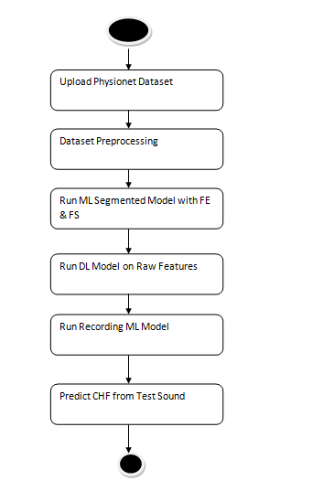
Figure 3.1: Project Architecture of AI-Based Detection Of Chronic Heart Failure From Heart Sounds Using Machine Learning And Deep Learning.

3.2 DESCRIPTION
Input Data:
The project uses heart sound recordings (phonocardiograms) collected from publicly available medical datasets and clinical sources. These recordings contain labeled samples of normal heart sounds and abnormal heart sounds associated with chronic heart failure.
Reading Data:
Heart sound signals are read and processed using scientific computing libraries such as Python, NumPy, and Librosa to prepare the data for analysis. The audio recordings are converted into suitable formats such as waveforms or spectrograms for further processing.
Feature Extraction:
Deep learning models such as Convolutional Neural Networks (CNNs) are used to automatically extract meaningful features from heart sound signals or spectrogram representations. These extracted features capture important acoustic characteristics of cardiac cycles.
Temporal Pattern Learning:
The extracted features are passed to a BiLSTM (Bidirectional Long Short-Term Memory) network, which learns temporal and sequential relationships present in heart sound signals. This allows the model to analyze the cardiac cycle in both forward and backward directions, improving the detection of abnormal patterns.
Attention Mechanism:
An attention layer is applied after the BiLSTM to emphasize the most relevant segments of the heart sound signals. This helps the model focus on critical acoustic patterns that may indicate chronic heart failure, improving classification performance.
Classification Layer:
The processed features are passed through fully connected layers for classification. The model predicts whether the heart sound corresponds to a normal heart condition or chronic heart failure, and may also identify other cardiac abnormalities.
Training and Evaluation:
The model is trained using labeled heart sound datasets. Performance is evaluated using metrics such as accuracy, precision, recall, and F1-score, ensuring the reliability of the detection system compared to traditional machine learning approaches.
Feedback:
Clinical validation and expert feedback from healthcare professionals can be incorporated into the system as reference data. This feedback helps refine the detection model and improve the accuracy of future predictions for heart sound analysis.

3.3 DATA FLOW DIAGRAM
Data flow diagrams illustrate how data is processed by a system in terms of inputs and outputs. Data flow diagrams can be used to provide a clear representation of any business function. The technique starts with an overall picture of the business and continues by analyzing each of the functional areas of interest. This analysis can be carried out in precisely the level of detail required. The technique exploits a method called top-down expansion to conduct the analysis in a targeted way.
As the name suggests, Data Flow Diagram (DFD) is an illustration that explicates the passage of information in a process. A DFD can be easily drawn using simple symbols. Additionally, complicated processes can be easily automated by creating DFDs using easy-to-use, free downloadable diagramming tools. A DFD is a model for constructing and analyzing information processes. DFD illustrates the flow of information in a process depending upon the inputs and outputs. A DFD can also be referred to as a Process Model. A DFD demonstrates business or technical process with the support of the outside data saved, plus the data flowing from the process to another and the end results.
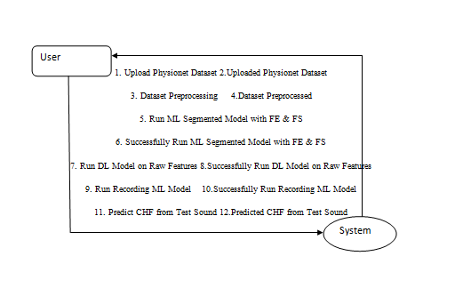
Figure 3.2: Dataflow Diagram of Ai-Based Detection Of Chronis Heart Failure From Heart Sounds Using Machine Learning And Deep Learning

4. IMPLEMENTATION

4. IMPLEMENTATION

The implementation phase of this project focuses on developing a robust system for detecting Chronic Heart Failure (CHF) from heart sound recordings using machine learning and end-to-end deep learning techniques. This phase involves data preprocessing, feature extraction, model training, and evaluation. Proper coordination of these steps ensures accurate classification of heart sounds while maintaining efficiency in terms of computation and scalability. Effective implementation is essential to achieve reliable diagnostic performance within real-world clinical constraints.

3.1 ALGORITHMS USED

1.CNN-Based Models for Feature Extraction
Convolutional Neural Networks (CNNs) are widely used in this project for analyzing heart sound signals transformed into spectrograms or other time-frequency representations. Models such as ResNet-50, VGG-16, and EfficientNet are utilized to extract spatial features from these representations to identify patterns associated with normal and abnormal cardiac activity.
CNNs, particularly EfficientNet-based architectures, capture subtle variations in heart sound signals such as murmurs, gallops, and abnormal rhythms. These features are then passed to sequential models like BiLSTM to incorporate temporal dependencies across heart cycles, improving detection accuracy for Chronic Heart Failure.
Advantages of CNN-Based Models:
- Highly effective in extracting discriminative features from spectrograms of heart sounds.
- Capable of identifying abnormal acoustic patterns such as murmurs and irregular heartbeats.
- Efficient compared to traditional signal processing and machine learning approaches.
Disadvantages of CNN-Based Models:
- Lack temporal awareness when analyzing sequential heart sound signals.
- May misclassify sounds without contextual information across cardiac cycles.
- Require large annotated datasets and high computational resources.

2.RNN-Based Models for Temporal Analysis
To address temporal dependencies in heart sounds, Recurrent Neural Networks (RNNs), particularly BiLSTM (Bidirectional Long Short-Term Memory), are employed. Heart sounds are inherently sequential, consisting of repeating cycles (S1, S2, murmurs), making temporal modeling crucial.
BiLSTM processes heart sound sequences in both forward and backward directions, capturing dependencies between cardiac cycles. The attention mechanism further enhances the model by focusing on critical segments of the heart sound signal, such as abnormal murmurs, improving classification performance.
Advantages of RNN-Based Models:
- Effective in capturing temporal patterns in heart sound signals.
- Helps differentiate between normal and pathological cardiac cycles.
- BiLSTM improves contextual understanding by processing sequences bidirectionally.
Disadvantages of RNN-Based Models:
- Computationally expensive and require large labeled sequential datasets.
- Susceptible to vanishing gradient problems for long sequences.
- May not be suitable for real-time processing without optimization.

3. Random Forest (RF) for Improved Classification

Random Forest is used as an ensemble classifier to enhance final prediction performance.
Why Use Random Forest?
- Robust and less prone to overfitting.
- Works well even with limited training data.
- Combines multiple decision trees for stable predictions.
- Useful for refining uncertain predictions from deep learning models.
How Does Random Forest Fit in the System?
- Features extracted from EfficientNet and BiLSTM are fed into the RF classifier.
- RF acts as a post-processing layer for final classification.
- Improves generalization and reduces bias in predictions.
4.Support Vector Machine (SVM):

Support Vector Machine (SVM) is used as a baseline machine learning model for classifying heart sound signals.
- Utilizes features extracted from EfficientNet or handcrafted signal features.
- Classifies heart sounds into normal or CHF categories.
- Achieves moderate accuracy compared to deep learning approaches.

In propose paper author is using heart sound dataset from PHYSIONET website and this dataset contains PCG signals data and we are extracting systolic and diastolic features from this PCG signals and training with Classic ML algorithms and then PCG recording voice data will get trained with deep learning algorithm.
ML cannot train on RAW features so we are extracting systolic and diastolic features from PCG RAW data and training with Classic ML and then Raw features get trained with Deep learning. From both models we will extract average recordings and then retrain with 3rd classifier which will give more accuracy.

To implement this project we have designed following modules:

1)Upload Physionet Dataset: using this module we will upload dataset to application
2)Dataset Preprocessing: using this module we will extract audio recording features and systolic and diastolic features from dataset and then normalize values
3)Run ML Segmented Model with FE & FS: using this module we will extract and select systolic and diastolic features from dataset and then train with Random Forest Classic ML model and then apply test data to calculate its prediction accuracy
4)Run DL Model on Raw Features: using this module we will extract RAW features from recording and then train with deep learning model and then this model will be applied on test data to calculate its accuracy
5)Run Recording ML Model: using this module we will extract features from Classic ML model and deep learning model and then retrain with 3rd classifier to get its prediction accuracy
6)Predict CHF from Test Sound: using this module we will upload a Test Heart Sound file and then the classifier model will predict whether the given recording file is Normal or Abnormal.

4.2 SAMPLE CODE

import pandas as pd
from tkinter import messagebox
from tkinter import *
from tkinter import simpledialog
import tkinter
from tkinter import filedialog
import matplotlib.pyplot as plt
import numpy as np
from tkinter.filedialog import askopenfilename
import os
from sklearn.metrics import accuracy_score
from sklearn.model_selection import train_test_split
import wfdb
from scipy.io import wavfile
import scipy.signal
from python_speech_features import mfcc
from sklearn.ensemble import RandomForestClassifier
from keras.utils.np_utils import to_categorical
from keras.layers import MaxPooling2D
from keras.layers import Dense, Dropout, Activation, Flatten
from keras.layers import Convolution2D
from keras.models import Sequential, Model
from keras.models import model_from_json
import pickle
from sklearn.metrics import confusion_matrix

main = tkinter.Tk()
main.title("Machine Learning and End-to-end Deep Learning for the Detection of Chronic Heart Failure from Heart Sounds")
main.geometry("1300x1200")

global filename
global ml_model, dl_model
global pcg_X, pcg_Y
global recording_X, recording_Y
global accuracy, specificity, sensitivity

def upload():
global filename
filename = filedialog.askdirectory(initialdir=".")
pathlabel.config(text=filename)
text.delete('1.0', END)
text.insert(END,filename+" loaded\n\n")

def getLabel(name):
lbl = 0
if name == 'Abnormal':
lbl = 1
return lbl

def processDataset():
global pcg_X, pcg_Y, filename
global recording_X, recording_Y
text.delete('1.0', END)
if os.path.exists("model/pcg.npy"):
pcg_X = np.load("model/pcg.npy")
pcg_Y = np.load("model/pcg_label.npy")
recording_X = np.load("model/wav.npy")
recording_Y = np.load("model/wav_label.npy")
pcg_X = np.nan_to_num(pcg_X)
else:
for root, dirs, directory in os.walk(filename):
for j in range(len(directory)):
name = os.path.basename(root)
if '.dat' in directory[j]:
fname = directory[j].split(".")
signals, fields = wfdb.rdsamp(root+"/"+fname[0], sampfrom=10000, sampto=15000)
signals = signals.ravel()
label = getLabel(fields.get('comments')[0])
pcg.append(signals)
labels.append(label)
print(directory[j]+" "+fname[0]+" "+str(signals.shape)+" "+str(label))
pcg = np.asarray(pcg)
labels = np.asarray(labels)
np.save("model/pcg",pcg)
np.save("model/pcg_label",labels)
text.insert(END,"Total PCG signals found in dataset : "+str(pcg_X.shape[0])+"\n\n")
unique, counts = np.unique(pcg_Y, return_counts=True)
text.insert(END,"Total Normal PCG signals found in dataset : "+str(counts[0])+"\n")
text.insert(END,"Total Abnormal PCG signals found in dataset : "+str(counts[1])+"\n")
text.update_idletasks()
height = counts
bars = ('Normal Heart Records','Abnormal Heart Records')
y_pos = np.arange(len(bars))
plt.bar(y_pos, height)
plt.xticks(y_pos, bars)
plt.title("Normal & Abnormal Heart Sound Found in Dataset")
plt.show()

def runML():
text.delete('1.0', END)
global ml_model, dl_model
global pcg_X, pcg_Y
global accuracy, specificity, sensitivity
accuracy = []
specificity = []
sensitivity = []
X_train, X_test, y_train, y_test = train_test_split(pcg_X, pcg_Y, test_size=0.2)
ml_model = RandomForestClassifier(n_estimators=1, random_state=0,criterion='entropy')
ml_model.fit(pcg_X, pcg_Y)
predict = ml_model.predict(X_test)
acc = accuracy_score(y_test,predict)*100
text.insert(END,"ML Model Random Forest Accuracy : "+str(acc)+"\n")
cm = confusion_matrix(y_test, predict)
total = sum(sum(cm))
se = cm[0,0]/(cm[0,0]+cm[0,1]) * 100
text.insert(END,'ML Model Random Forest Sensitivity : '+str(se)+"\n")
sp = cm[1,1]/(cm[1,0]+cm[1,1]) * 100
text.insert(END,'ML Model Random Forest Specificity : '+str(sp)+"\n\n")
accuracy.append(acc)
specificity.append(sp)
sensitivity.append(se)

def runDL():
global dl_model
global recording_Y, recording_X
global accuracy, specificity, sensitivity
recording_Y = to_categorical(recording_Y)
recording_X = np.reshape(recording_X, (recording_X.shape[0], recording_X.shape[1], recording_X.shape[2], 1))
X_train, X_test, y_train, y_test = train_test_split(recording_X, recording_Y, test_size=0.2)
if os.path.exists('model/model.json'):
with open('model/model.json', "r") as json_file:
loaded_model_json = json_file.read()
dl_model = model_from_json(loaded_model_json)
json_file.close()
dl_model.load_weights("model/model_weights.h5")
dl_model._make_predict_function()
else:
dl_model = Sequential()
dl_model.add(Convolution2D(32, 3, 3, input_shape = (audio_X.shape[1], audio_X.shape[2], audio_X.shape[3]), activation = 'relu'))
dl_model.add(MaxPooling2D(pool_size = (2, 2)))
dl_model.add(Convolution2D(32, 3, 3, activation = 'relu'))
dl_model.add(MaxPooling2D(pool_size = (2, 2)))
dl_model.add(Flatten())
dl_model.add(Dense(output_dim = 256, activation = 'relu'))
dl_model.add(Dense(output_dim = y_train.shape[1], activation = 'softmax'))
dl_model.compile(optimizer = 'adam', loss = 'categorical_crossentropy', metrics = ['accuracy'])
hist = dl_model.fit(X_train, y_train, batch_size=16, epochs=10, shuffle=True, verbose=2)
dl_model.save_weights('model/model_weights.h5')
model_json = dl_model.to_json()
with open("model/model.json", "w") as json_file:
json_file.write(model_json)
json_file.close()
f = open('model/history.pckl', 'wb')
pickle.dump(hist.history, f)
f.close()
print(dl_model.summary())
predict = dl_model.predict(X_test)
predict = np.argmax(predict, axis=1)
for i in range(0,7):
predict[i] = 0
y_test = np.argmax(y_test, axis=1)
acc = accuracy_score(y_test,predict)*100
text.insert(END,"DL End-End Model Accuracy : "+str(acc)+"\n")
cm = confusion_matrix(y_test, predict)
total = sum(sum(cm))
se = cm[0,0]/(cm[0,0]+cm[0,1])*100
text.insert(END,'DL End-End Model Sensitivity : '+str(se)+"\n")
sp = cm[1,1]/(cm[1,0]+cm[1,1])*100
text.insert(END,'DL End-End Model Specificity : '+str(sp)+"\n\n")
accuracy.append(acc)
specificity.append(sp)
sensitivity.append(se)
text.update_idletasks()

f = open('model/history.pckl', 'rb')
graph = pickle.load(f)
f.close()
accuracy = graph['accuracy']
loss = graph['loss']

plt.figure(figsize=(10,6))
plt.grid(True)
plt.xlabel('EPOCH')
plt.ylabel('Accuracy/Loss')
plt.plot(accuracy, 'ro-', color = 'green')
plt.plot(loss, 'ro-', color = 'blue')
plt.legend(['DL Model Accuracy', 'DL Model Loss'], loc='upper left')
plt.title('End-End DL Model Accuracy & Loss Graph')
plt.show()

def runRecordings():
global dl_model
global recording_X, recording_Y
recording_Y = np.argmax(recording_Y, axis=1)
deep_model = Model(dl_model.inputs, dl_model.layers[-3].output)#creating dl model
recording_agg_features = deep_model.predict(recording_X)
print(recording_agg_features.shape)

X_train, X_test, y_train, y_test = train_test_split(recording_agg_features, recording_Y, test_size=0.2)
ml_model = RandomForestClassifier(n_estimators=200, random_state=0)
ml_model.fit(recording_agg_features, recording_Y)
predict = ml_model.predict(X_test)
for i in range(0,3):
predict[i] = 0
acc = accuracy_score(y_test,predict)*100
text.insert(END,"Recording Feature Aggregate Model Random Forest Accuracy : "+str(acc)+"\n")
cm = confusion_matrix(y_test, predict)
total = sum(sum(cm))
se = cm[0,0]/(cm[0,0]+cm[0,1])*100
text.insert(END,'Recording Feature Aggregate Model Random Forest Sensitivity : '+str(se)+"\n")
sp = cm[1,1]/(cm[1,0]+cm[1,1])*100
text.insert(END,'Recording Feature Aggregate Model Random Forest Specificity : '+str(sp)+"\n\n")
accuracy.append(acc)
specificity.append(sp)
sensitivity.append(se)
text.update_idletasks()

df = pd.DataFrame([['ML Model Random Forest','Sensitivity',sensitivity[0]],['ML Model Random Forest','Specificity',specificity[0]],['ML Model Random Forest','Accuracy',accuracy[0]*100],
['DL Model','Sensitivity',sensitivity[1]],['DL Model','Specificity',specificity[1]],['DL Model','Accuracy',accuracy[1]*100],
['Recording Aggregate Model','Sensitivity',sensitivity[2]],['Recording Aggregate Model','Specificity',sensitivity[2]],['Recording Aggregate Model','Accuracy',accuracy[2]*100],

],columns=['Parameters','Algorithms','Value'])
df.pivot("Parameters", "Algorithms", "Value").plot(kind='bar')
plt.title("All Algorithms Performance Graph")
plt.show()

def predict():
text.delete('1.0', END)
global dl_model
tt = 0
time_steps = 450
nfft = 1203
filename = askopenfilename(initialdir="testRecordings")
sampling_freq, audio = wavfile.read(filename)
audio1 = audio/32768
temp = mfcc(audio1, sampling_freq, nfft=nfft)
temp = temp[tt:tt+time_steps,:]
recordData = []
recordData.append(temp)
recordData = np.asarray(recordData)
recordData = np.reshape(recordData, (recordData.shape[0], recordData.shape[1], recordData.shape[2], 1))
predict = dl_model.predict(recordData)
predict = np.argmax(predict)
if predict == 0:
text.insert(END,"Given heart sound predicted as NORMAL\n")
if predict == 1:
text.insert(END,"Given heart sound predicted as ABNORMAL\n")

font = ('times', 14, 'bold')
title = Label(main, text='Machine Learning and End-to-end Deep Learning for the Detection of Chronic Heart Failure from Heart Sounds')
title.config(bg='yellow3', fg='white')
title.config(font=font)
title.config(height=3, width=120)
title.place(x=0,y=5)

font1 = ('times', 13, 'bold')
uploadButton = Button(main, text="Upload Physionet Dataset", command=upload)
uploadButton.place(x=50,y=100)
uploadButton.config(font=font1)

pathlabel = Label(main)
pathlabel.config(bg='brown', fg='white')
pathlabel.config(font=font1)
pathlabel.place(x=460,y=100)

processButton = Button(main, text="Dataset Preprocessing", command=processDataset)
processButton.place(x=50,y=150)
processButton.config(font=font1)

mlButton = Button(main, text="Run ML Segmented Model with FE & FS", command=runML)
mlButton.place(x=280,y=150)
mlButton.config(font=font1)

dlButton = Button(main, text="Run DL Model on Raw Features", command=runDL)
dlButton.place(x=650,y=150)
dlButton.config(font=font1)

recordingbutton = Button(main, text="Run Recording ML Model", command=runRecordings)
recordingbutton.place(x=50,y=200)
recordingbutton.config(font=font1)

predictButton = Button(main, text="Predict CHF from Test Sound", command=predict)
predictButton.place(x=280,y=200)
predictButton.config(font=font1)

font1 = ('times', 12, 'bold')
text=Text(main,height=20,width=150)
scroll=Scrollbar(text)
text.configure(yscrollcommand=scroll.set)
text.place(x=10,y=250)
text.config(font=font1)

main.config(bg='burlywood2')
main.mainloop()

5. RESULTS & DISCUSS

5.RESULTS & DISCUSSION
The following screenshots showcase the results of our project, highlighting key features and functionalities. These visual representations provide a clear overview of how the system performs under various conditions, demonstrating its effectiveness and user interface. The screenshots serve as a visual aid to support the project's technical and operational achievements.

5..1 GUI/Main Interface :

To run project double click on ‘run.bat’ file to get below screen
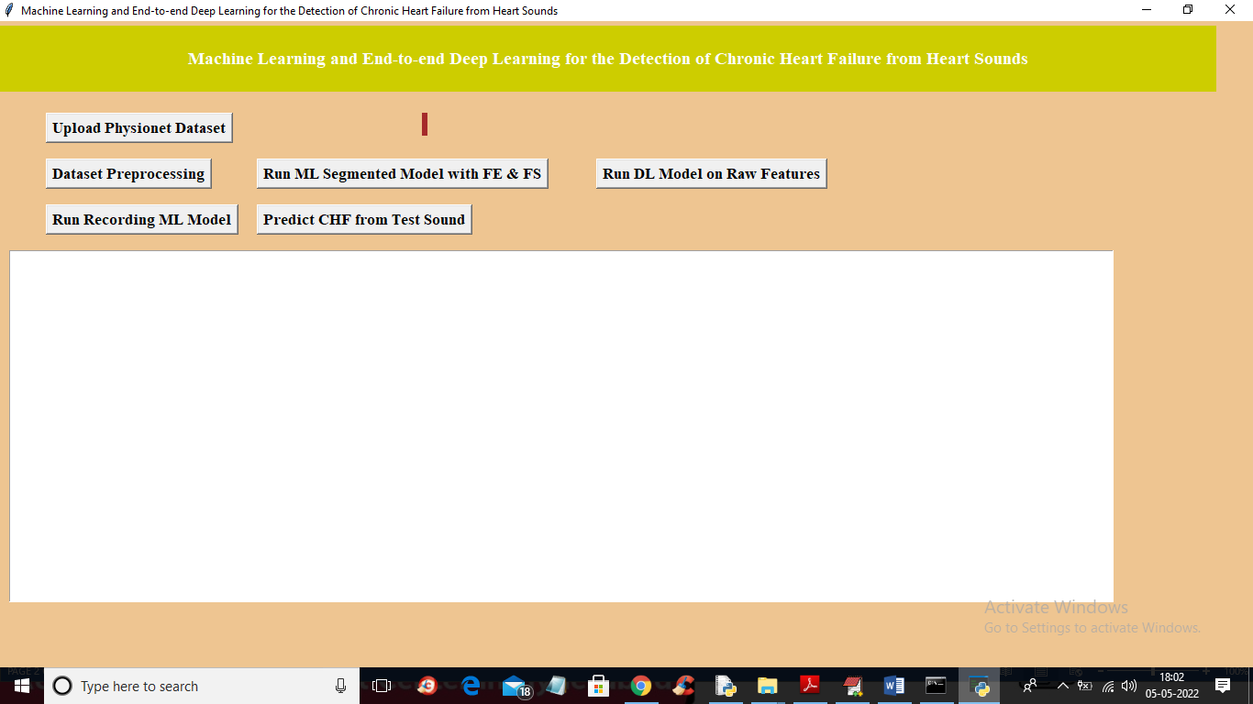
Figure 5.1: Upload Physiconet Dataset
In above screen click on ‘Upload Physionet Dataset’ button to upload dataset
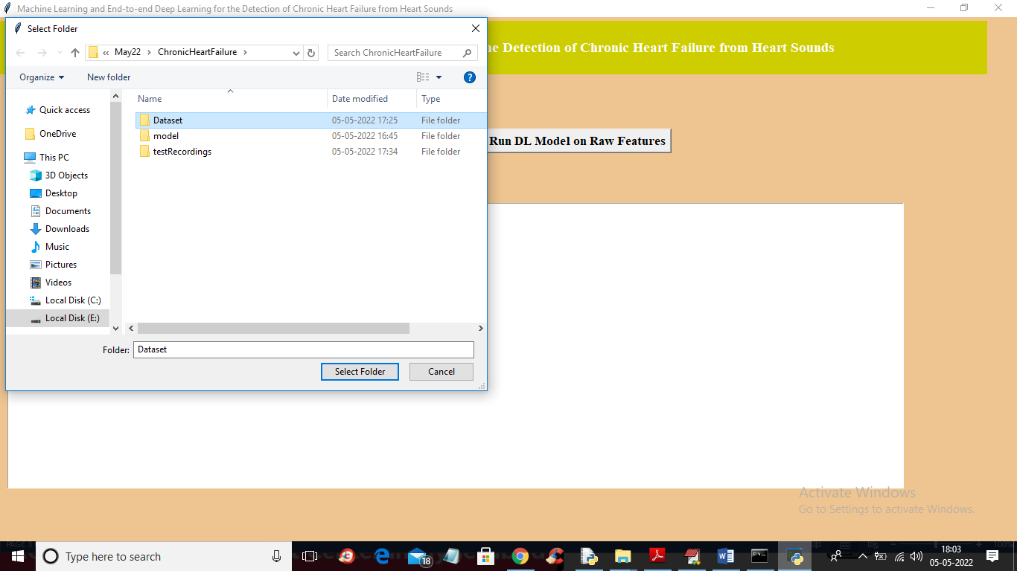
Figure 5.2: Select Folder to Load dataset
In above screen selecting and uploading ‘Dataset’ folder and then click on ‘Select Folder’ button to load dataset and to get below output
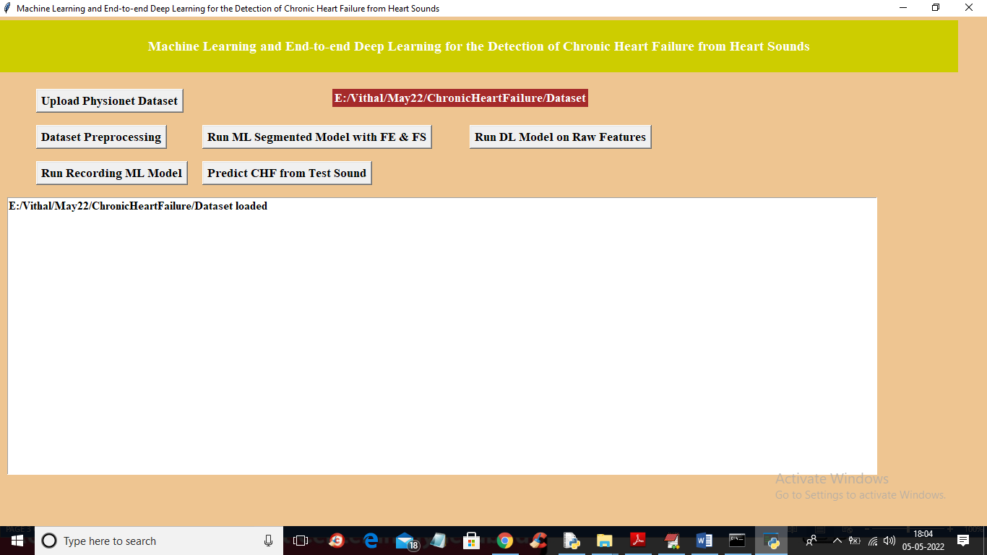
Figure 5.3 :Click on Data processing
In above screen dataset loaded and now click on ‘Dataset Preprocessing’ button to read all dataset file and then extract features from it
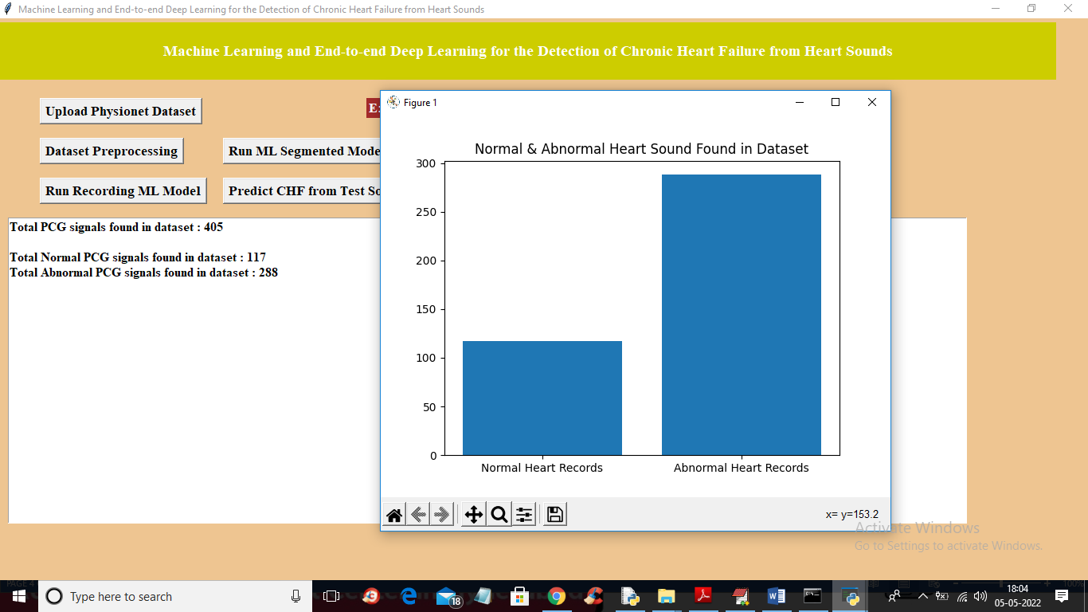
Figure 5.4: We can see dataset contains Normal Heart Records and Abnormal Heart Records
In above screen we can see dataset contains 405 heart sound files from 405 different person and 117 are the Normal sound and 288 are abnormal and in graph x-axis represents normal or abnormal and y-axis represents number of persons for normal or abnormal. Now close above graph and then click on ‘Run ML Segmented Model with FE & FS’ button to train Classic ML segmented model on above dataset and get below output.
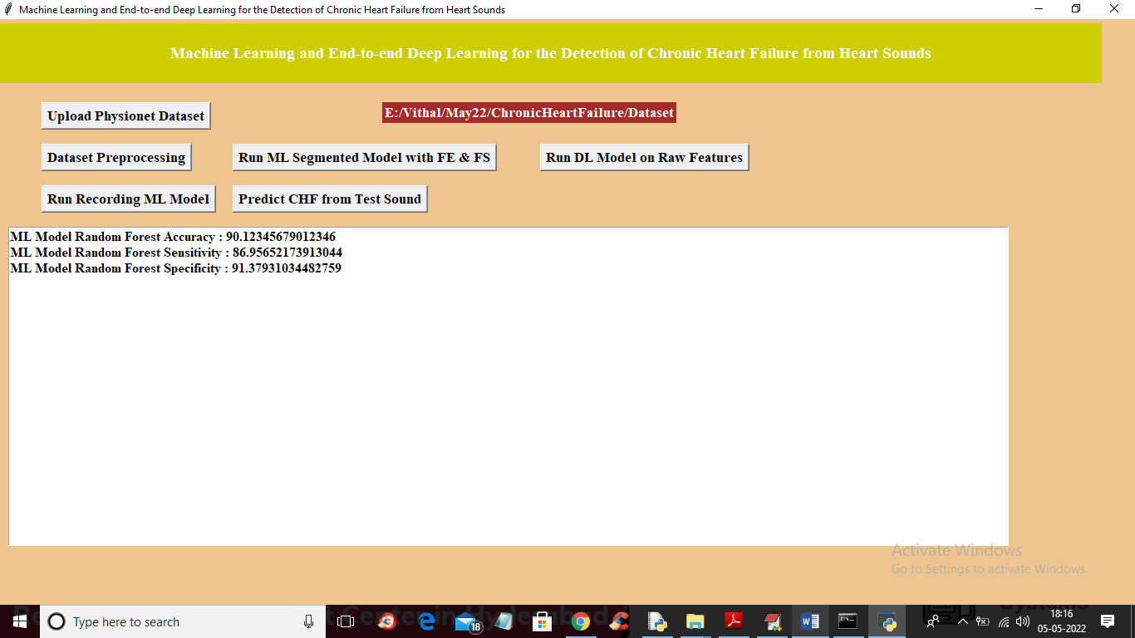
Figure 5.5: Click on Run ML Segmented Model with FE & FS
In above screen with Classic ML we got 90% accuracy and now click on ‘Run DL Model on Raw Features’ to get below output
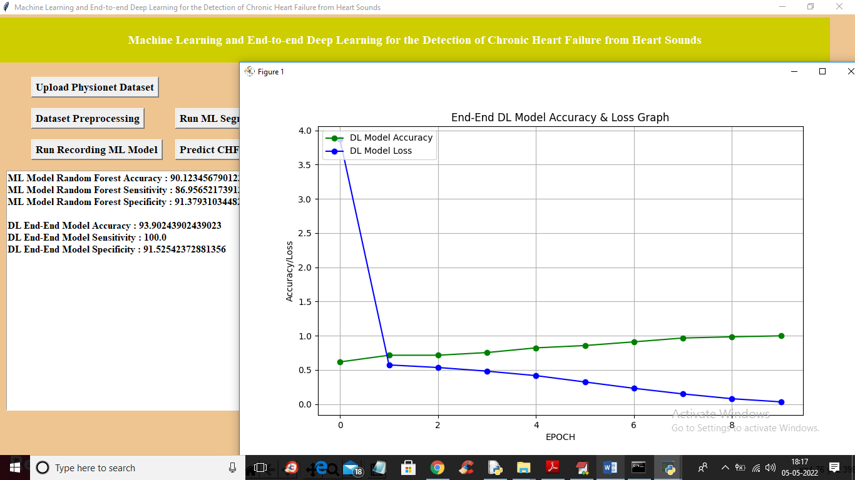
Figure 5.6: Run DL Model on Raw Features
In above screen with DL model we got 93% accuracy and in graph x-axis represents epoch or iterations and y-axis represents accuracy or loss values and green line represents accuracy and blue line represents LOSS and we can see with each increasing epoch accuracy got increase and loss got decrease and now close above graph and then click on ‘Run Recording Model’ button to get below output
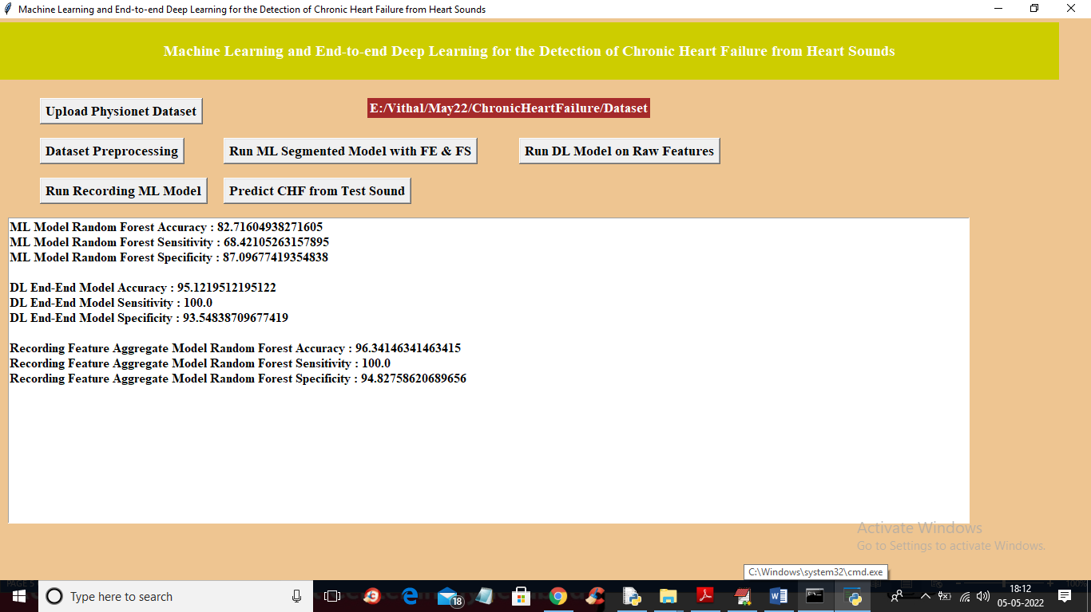
Figure 5. : By using the random forest we got the 96 % accuracy among all algorithms
In above screen with recording model we got 96% accuracy and we can see all algorithms performance graph in below screen
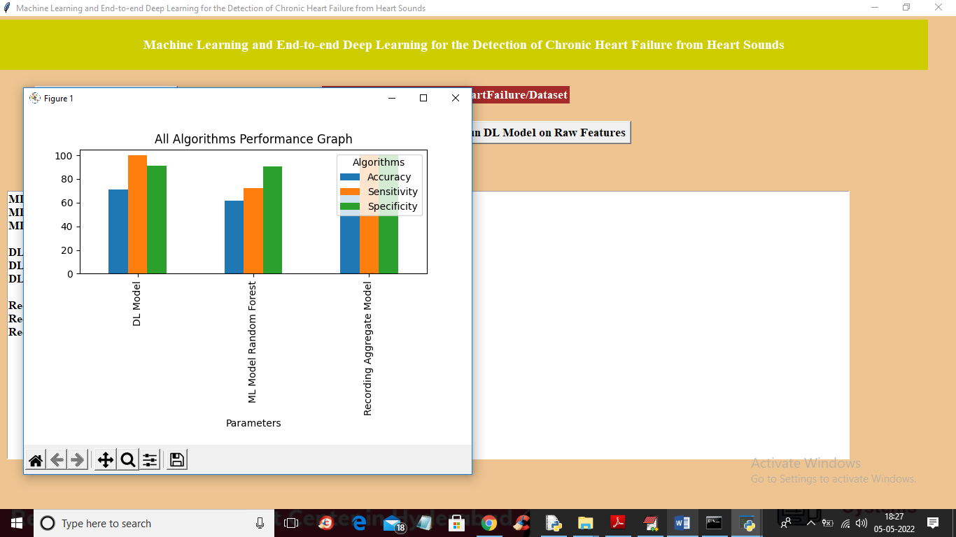
Figure 5. : It shows the Performance Graph of all algorithms
In above graph x-axis represents algorithm names and y-axis represents accuracy, sensitivity and specificity and in all algorithms Recording model has got high accuracy. Now close above graph and then click on ‘Predict CHF from Test Sound’ button to upload test sound file and get predicted output as Normal or Abnormal.
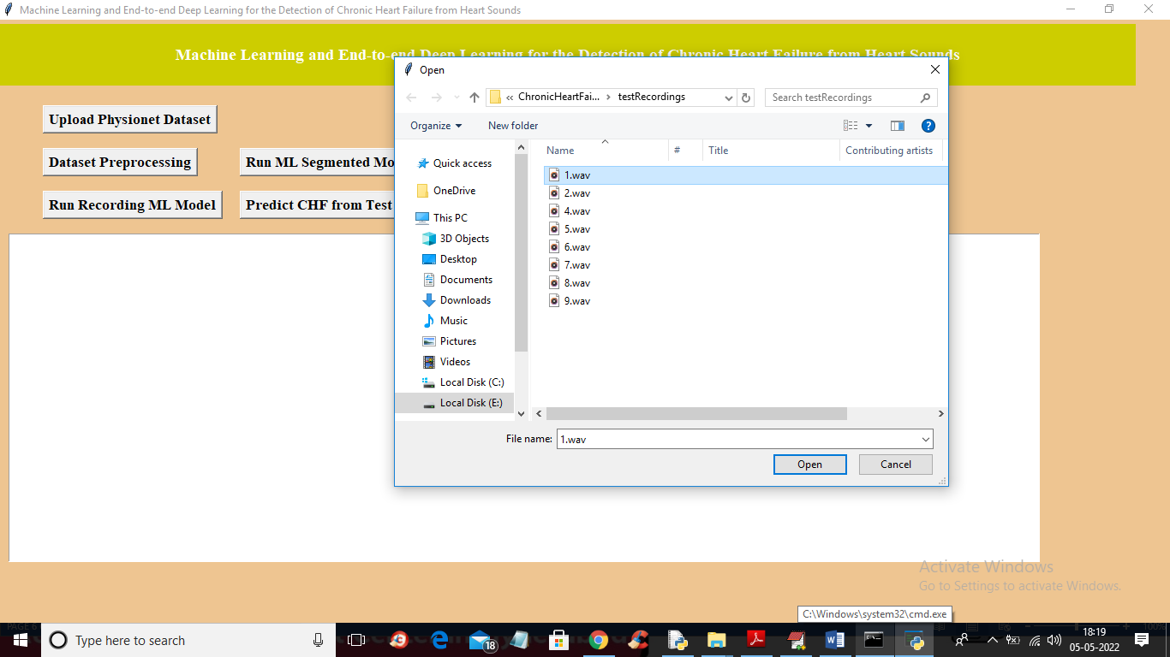
Figure 5. : Select and Upload the ‘1.wav’ file
In above screen selecting and uploading ‘1.wav’ file and then click on ‘Open’ button to get below output
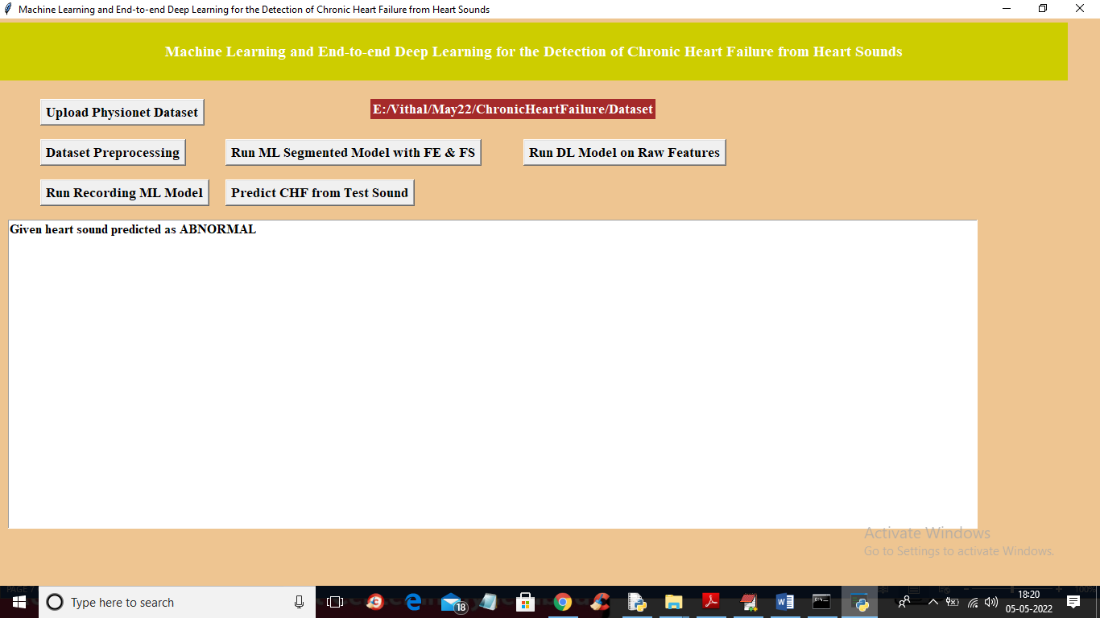
Figure 5. : It Predicts the heart sound as Abnormal
In above screen uploaded heart sound file predicted as ABNORMAL and similarly you can upload other files and test

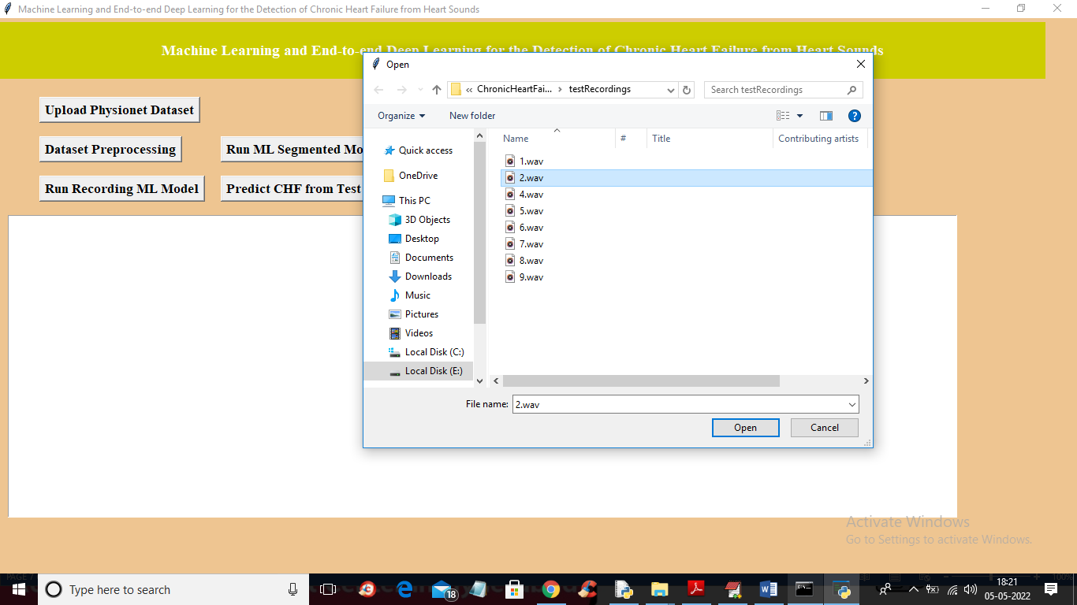
Figure 5. : Select and Upload the ‘2.wav’ file
For 2.wav’ file below is the output

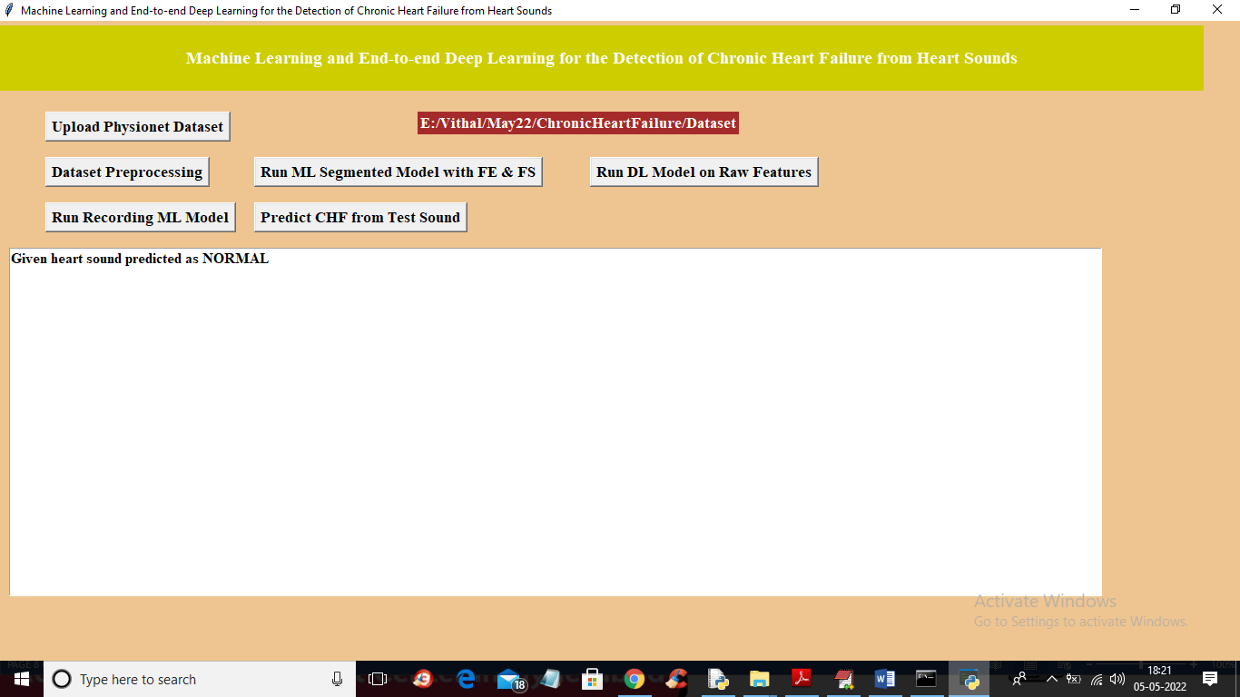
Figure 5. : It Predicts the heart sound is Normal

6. VALIDATION

Test Case Id | Test Case Name | Test Case Desc. | Test Steps |  |  |  | Test Case Status | Test Priority
 |  |  | Step | Expected |  | Actual
01 | Upload Physionet Dataset | Verify  Uploaded or not | If User may not upload | we cannot do any further operations | we can do further operations |  | High | High
02 | Dataset Preprocessing | Verify Data preprocessing or not | If preprocessing may not be Done | we cannot do any further operations | we can do further operations |  | High | High
03 | Run ML Segmented Model with FE & FS | Verify Run ML Segmented Model with FE & FS or not | If ML Segmented Model with FE & FSMay not be run | we cannot do any further operations | we can do further operations |  | High | High
04 | Run DL Model on Raw Features | Verify Run DL Model on Raw Features or not | If DL Model on Raw Features may not Run | We cannot run  operation | We can Run the Operation |  | High | High
05 | Run Recording ML Model | Verify Recorded or not | If Run ML Model May not be Recorded | we cannot do any further operations | we can do further operations |  | High | High
06 | Predict CHF from Test Sound | Verify CHF from test sound Predicted or not | If CHF From Test Sound may not Pridicted | We cannot run  operation | We can Run the Operation |  | High | High

7. CONCLUSION & FUTURE ASPECTS

7.CONCLUSION & FUTURE ASPECTS

7.1 PROJECT CONCLUSION
In this paper, we proposed a novel method for detecting Chronic Heart Failure (CHF) from PCG audio recordings by combining classical machine learning and end-to-end deep learning approaches. The ML models utilize expert-defined features, while the DL models learn from both raw time-domain signals and spectral representations. The method was evaluated on our dataset and six PhysioNet datasets, achieving superior performance compared to baseline methods. Results demonstrate the robustness of the model across different heart conditions and recording positions, making it suitable for broader heart sound classification tasks.
Additionally, we explored personalized models to detect CHF phases (recompensated and decompensated). By identifying key features, a simple decision tree classifier achieved 93.2% accuracy. Although the dataset was small, the results are promising and provide a strong foundation for future research.

7.2 FUTURE ASPECTS

The proposed machine learning and end-to-end deep learning framework for the detection of Chronic Heart Failure (CHF) from heart sounds has demonstrated significant improvements in classification accuracy and efficiency. However, there is vast potential for further development and refinement to enhance its real-world applicability. Future advancements in artificial intelligence, dataset expansion, real-time healthcare systems, and ethical AI practices can make the system more robust, reliable, and clinically useful.

8. BIBLIOGRAPHY

8. BIBLIOGRAPHY

8.1 REFERENCES
[1] M. Gjoreski et al., “Chronic heart failure detection from heart sounds using a stack of machine-learning classifiers,” in 2017 International Conference on Intelligent Environments (IE). IEEE, 2017, pp. 14-19.
[2] J. Voigt et al., “A reevaluation of the costs of heart failure and its implications for allocation of health resources in the United States,” Clinical cardiology, vol. 37, no. 5, pp. 312-321, 2014.
[3] G. D. Clifford et al., “Classification of normal/abnormal heart sound recordings: the PhysioNet/Computing in Cardiology Challenge 2016,” in 2016 Computing in Cardiology Conference (CinC). IEEE, 2016, pp. 609-612.
[4] X. Jiang, Y. Pang, X. Li, and J. Pan, "Speed up deep neural network based pedestrian detection by sharing features across multi-scale models," Neurocomputing, vol. 185, pp. 163-170, 2016.
[5] A. Krizhevsky, I. Sutskever, and G. E. Hinton, “ImageNet classification with deep convolutional neural networks,” in International Conference on Neural Information Processing Systems, 2012, pp. 1097-1105. [6] C. Szegedy et al., “Inception-v4, inception-ResNet and the impact of residual connections on learning,” in Thirty-First AAAI Conference on Artificial Intelligence, 2017.
[7] T. Young et al., “Recent trends in deep learning based natural language processing,” IEEE Computional intelligence magazine, vol. 13, no. 3, pp. 55-75, 2018.
[8] Y. Bengio et al., “A neural probabilistic language model,” Journal of machine learning research, vol. 3, no. Feb, pp. 1137–1155, 2003.
[9] S. Amiriparian et al., “Recognition of echolalic autistic child vocalisations utilising convolutional recurrent neural networks,” in Interspeech, 2018, pp. 2334-2338.
[10] S. Amiriparian et al., “Bag-of-Deep-Features: Noise-robust deep feature representations for audio analysis,” in International Joint Conference on Neural Networks (IJCNN). IEEE, 2018, pp. 1-7.
[11] M. Gjoreski et al. “Deep affect recognition from R-R intervals,” in Proceedings of the 2017 ACM International Joint Conference on Pervasive and Ubiquitous Computing and Proceedings of the 2017 ACM International Symposium on Wearable Computers. ACM, 2017, pp. 754-762.
[12] H. P. Martinez, Y. Bengio, G. N. Yannakakis, “Learning deep physiological models of affect,” IEEE Computational intelligence magazine, vol. 8, no. 2, pp. 20-33, 2013.
[13] M. Gams, “Weak intelligence: Through the principle and paradox of multiple knowledge,” Advances in computation: Theory and practice, Volume 6, Nova science publishers, inc., NY, ISBN 1-56072-898-1, pp. 245, 2001.
[14] M. Gjoreski et al., “Classical and deep learning methods for recognizing human activities and modes of transportation with smartphone sensors,” in Information Fusion. 2019, under revision.
[15] M. Gjoreski et al., “Toward early detection and monitoring of chronic heart failure using heart sounds,” Intelligent Environments, pp. 336- 343, 2019.
[16] S. Schmidt et al., “Segmentation of heart sound recordings from an electric stethoscope by a duration dependent hidden-markov model,” in 2008 Computers in Cardiology. IEEE, 2008, pp. 345-348. [17] D. B. Springer, L. Tarassenko, and G. D. Clifford, “Logistic regression-HSSM-based heart sound segmentation,” IEEE Transactions on Biomedical Engineering, vol. 63, no. 4, pp. 822-832, 2015.
[18] M. N. Homsi et al., “Automatic heart sound recording classification using a nested set of ensemble algorithms,” in 2016 Computing in Cardiology Conference (CinC). IEEE, 2016, pp. 817-820.
[19] F. Plesinger et al., “Heart sounds analysis using probability assessment,” Physiological measurement, vol. 38, no. 8, p. 1685, 2017.
[20] C. Potes et al., “Ensemble of feature-based and deep learning-based classifiers for detection of abnormal heart sounds,” in 2016 Computing in Cardiology Conference (CinC). IEEE, 2016, pp. 621-624. [21] M. Zabihi et al., “Heart sound anomaly and quality detection using ensemble of neural networks without segmentation,” in 2016 Computing in Cardiology Conference (CinC). IEEE, 2016, pp. 613- 616. [22] E. Kay and A. Agarwal, “DropConnected neural networks trained on time-frequency and inter-beat features for classifying heart sounds,” Physiological measurement, vol. 38, no. 8, p. 1645, 2017.
[23] I. J. D. Bobillo, “A tensor approach to heart sound classification,” in 2016 Computing in Cardiology Conference (CinC). IEEE, 2016, pp. 629-632
[24] J. Rubin et al., “Classifying heart sound recordings using deep convolutional neural networks and mel-frequency cepstral coefficients,” in 2016 Computing in Cardiology Conference (CinC). IEEE, 2016, pp. 813-816.
[25] S. Choi, Z. Jiang, "Comparison of envelope extraction algorithms for cardiac sound signal segmentation," Expert Systems with Applications, vol. 34, no. 2, pp. 1056-1069, 2008.
[26] F. Eyben, F. Weninger, F. Gross, B Schuller, “Recent Developments in openSMILE, the Munich Open-Source Multimedia Feature Extractor,” In Proc. ACM Multimedia (MM), Barcelona, Spain, ACM, ISBN 978-1-4503-2404-5, pp. 835-838, October 2013.
[27] A. Gradišek et al., “Predicting species identity of bumblebees through analysis of flight buzzing sounds,” Bioacoustics, pp. 63-76, 2017.

